Saturday August 20th 8pm
DENVER

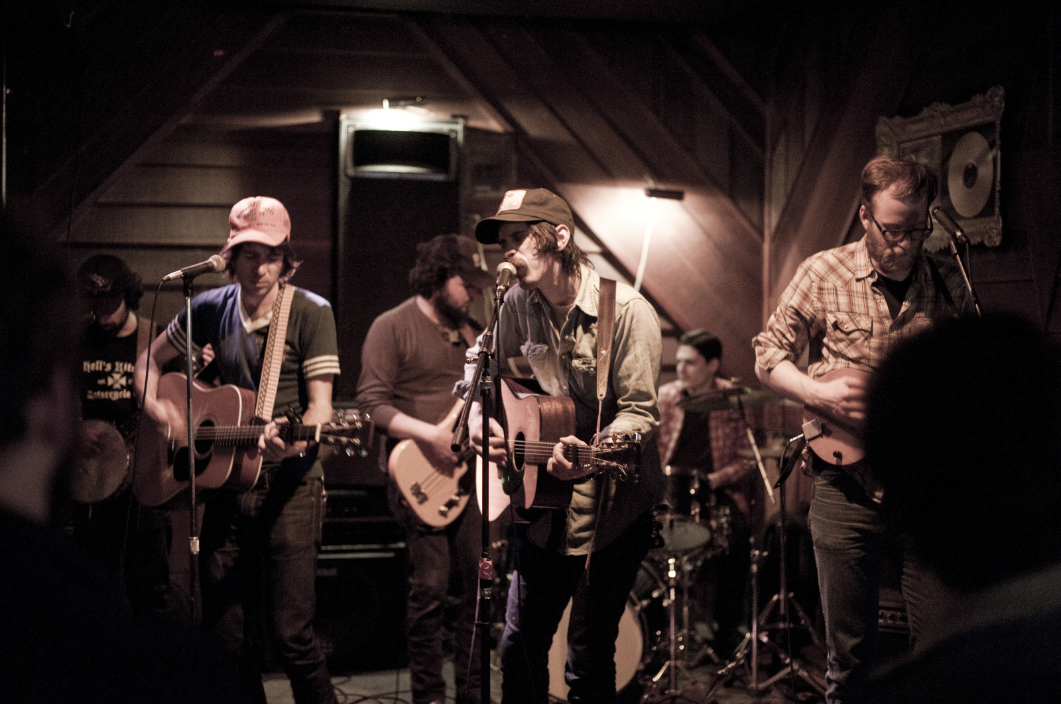

Sharing vocal and songwriting duties, Birger Olsen, Mike Elias and Tom Bevitori are the heart of Denver, while the rest of the line-up has long included several of Portland’s finest players. Currently, the band consists of drummer Sean MacNeil, bassist Billy Slater (Grails) and the legendary Lewi Longmire on lead guitar. Past and future editions include Blitzen Trapper’s Eric Earley and Michael Van Pelt, Ben Nugent (Dolorean), Ryan Spellman (Quiet Life), Ray Raposa (Castanets), Tom Menig and many others.
Paste praised their 2012 self-titled debut’s “perfect tunes,” while KEXP hosted a live session and proclaimed, “sweet harmonies and tight arrangements abound.” Statements like these become all the more relevant with their upcoming release, Rowdy Love, as Denver teamed up with Earley and Adam Selzer (M. Ward, Norfolk & Western) for their first trip to a proper studio. Recorded live in just two days at Selzer’s Type Foundry Studio, Rowdy Love certainly showcases all the endless chops at Denver’s disposal.
The record’s true focus, however, lies in the rare way Olsen, Elias and Bevitori’s distinct voices co-exist. There’s a natural melding of styles that’s evolved from afternoons on Olsen’s back porch, late night’s around Elias’ fire pit, and every last time they’ve nailed “The Weight” harmonies at the old Triple Nickel. Denver’s three songwriters may come to the process with varying style and influences, but Denver’s songwriting is universally honest and bare, whiskey-fueled, sweat-soaked, and steeped in working class life. Some might call it country. Some might call it rock. Some might call it a few drunks on a stage. Either way, bullshit and irony have no home here.

