Sunday August 21st 8pm
FESTIVAL OF FRIENDS
Featuring Tara Jane O’Neil*Geoff Soule*Katy Davidson*Cynthia Nelson

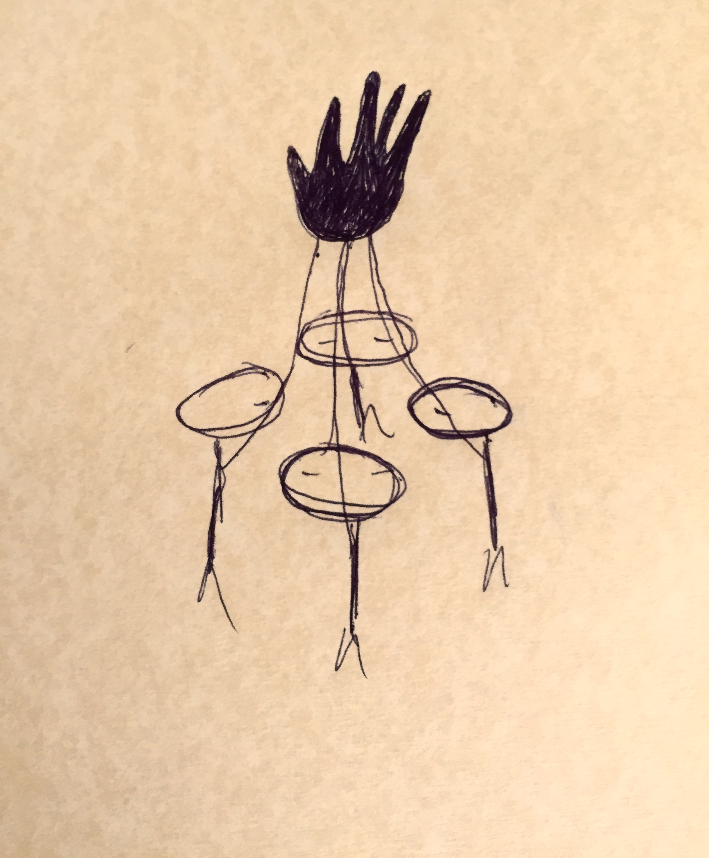

Tara Jane ONeil is a multi-instrumentalist, composer, and visual artist. She creates melodic and experimental music under her own name and in collaboration with her brilliant friends. Her recordings and live performances range from solo songing to noise improvisations. TJO has composed and performed music and sound for films, theater and dance performances, and written large and small ensemble experimental architectures.
Hello. I am Katy Davidson and I am a composer, producer, and multi-instrumentalist. I write and record music that spans a spectrum of genres ranging from melodic to experimental. I place emphasis on writing lyrics with layered meanings, often exploring the realms of nature, simulation, and technology. I am influenced equally by pop music, outsider music, ethereal music, dark synth music, classic rock, and music commonly played in Southwestern outdoor malls. My work has been called “feminine and confident” (Chicago Reader) “hymnlike” and “capable of humor, profundity and just plain poetry” (Willamette Week). I have toured the Americas, Europe, Australia, and Japan consistently for the last 15 years, with Gossip (2012-2014), YACHT (2011), Key Losers (my band, 2010-present), Lloyd & Michael (my collaborative duo with professor Marianna Ritchey, 2007-present), and Dear Nora (my band, 2000-2008). My recordings have been licensed in the US, Japan, and Australia. I am currently making an album that is equal parts heart-achingly beautiful and darkly aggressive. It will be released sometime before 2025.

